VOLUNTEER CENTER OF SHEBOYGAN COUNTY
AGENCY GUIDE
What’s inside?
- Volunteer Center Network Benefits (page 2)
- How to sign up your agency (page 3)
- How to add a volunteer opportunity (page 4)
- How to add a volunteer opportunity or wish list to an advanced event – Day of Caring or Holiday Needs! (page 5)
- How to list your volunteer opportunities (page 6)

GENERAL VOLUNTEER CENTER BENEFITS
All nonprofits within Sheboygan County are invited to join the Volunteer Center Network (VCN)! As a VCN member, your agency can access all the marketing opportunities and other resources provided by United Way's Volunteer Center to help you keep your volunteer base strong.
Benefits of joining the Volunteer Center Network:
- Joining a network of more than 100 nonprofit agencies to find new solutions to volunteer needs.
- Gain another avenue to find new volunteers by posting volunteer opportunities on the Volunteer Center Website.
- United Way of Sheboygan County (UWSC) serves as a connector between the nonprofit sector and businesses by connecting your agency with corporate volunteer groups when available.
By joining the VCN you gain access to the following outreach opportunities:
- Radio Air Time - United Way has a partnership with Midwest Communications that allows us to interview any nonprofit agency a part of the Volunteer Center Network at no cost to the agency. Radio spots are limited to once per calendar year to ensure everyone has a chance to share their updates on air.
- Outdoor Digital Sign on Kohler Memorial - Utilize our digital outdoor sign to promote your volunteer opportunities. Reservations are good for one week at a time.
- Visibility during our Annual Events - Day of Caring and Spirit of Sheboygan County Volunteer Awards are two events that help spread awareness for your agency's dedication to your mission!
- Social Media – Follow United Way of Sheboygan County and we’ll watch for your content to share out! (https://www.facebook.com/unitedwaysheboygancounty)
HOW TO SIGN UP YOUR AGENCY
- Visit http://www.uwofsc.org/volunteer and click the yellow ‘SIGN UP’ button on the top of the browser
  - Create an account by filling out the information
- Verify your account by watching for a verification email
- Login your account
- Click on ‘My Agency’ at the top of your window
- Click on ‘EDIT’
- Then add your information under each section. If you are not sure what goes in each section, you can hover over the question mark icons next to the section in question on the website.
- Save your work by clicking any of the ‘UPDATE AGENCY INFO’ blue buttons for each section
To double-check your work and to see what a volunteer will see on your agency profile by clicking on the ‘VIEW’ tab.

HOW TO ADD A VOLUNTEER OPPORTUNITY
- Login your account
- Click on ‘My Agency’ at the top of your window
- Click on ‘VOLUNTEER OPPORUTNITIES’ in the middle of your screen
- Click the blue ‘ADD NEW OPPORTNITY’ button on the right
- Then fill out the title, description, duration, etc. for your volunteer opportunity
  - Note: We suggest you add your agency contact information to the description area for the volunteer’s quick reference.
  - Note: When you select a ‘Duration’ this cannot be changed at a later time
  - Make sure to click Family Friendly for opportunities that the whole family can participate. We frequently receive inquires about these types of opportunities
  - Additional to the event description, be sure to add any specific requirements for this opportunity (such as tools) under ‘Attributes’
  - If you would another person to be notified of a volunteer responding to this request, add their email to the ‘Additional Notification Recipient(s)’ section on the bottom
  - Add a waiver if necessary
- Then click the blue ‘Create Opportunity’ to complete the process
- If needed: Use the red ‘DEACTIVATE OPPORTNITY’ button on the bottom of your screen
To view your listing, an ‘OPPORTUNITY LINK’ will populate on the right of your screen. Copy and paste that into your browser to view and share your opportunity.
To update or deactivate your opportunity later, go to ‘VOLUNTEER OPPORTNITIES’ then click ‘Edit’ under the volunteer opportunity you want to deactivate or update.

HOW TO ADD A DAY OF CARING OR HOLIDAY NEED
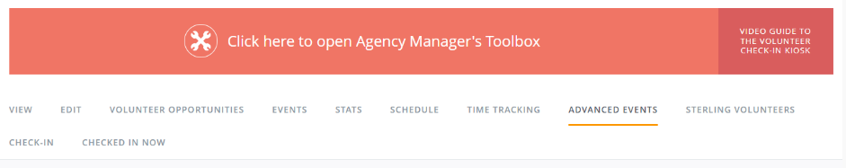
- Log into your account and click on ‘My Agency’ on the top window (Note: if your account isn’t connected to your agency’s listing, please contact United Way to get connected.)
- Click ‘Advanced Events.’
- Choose the ‘Event’ (this would be either Day of Caring or Holiday Wish List/Needs)
- Click ‘Add New Opportunity’
- Click ‘Create Opportunity’ to submit the volunteer opportunity and repeat for each opportunity you want to list
  - Note: all opportunities will be approved by UWSC staff prior to posting on the website. Once approved then you will see your opportunity available here: https://volunteersheboygan.galaxydigital.com/aem/general/ (NOTE: when an opportunity is full, then the listing will be taken off the list automatically)

How to download the volunteers that signed-up for your opportunity:
- Log into your account and click on ‘My Agency’ on the top window
- Click ‘Advanced Events’ and then click on the corresponding type of volunteer opportunity to find and click on your listing
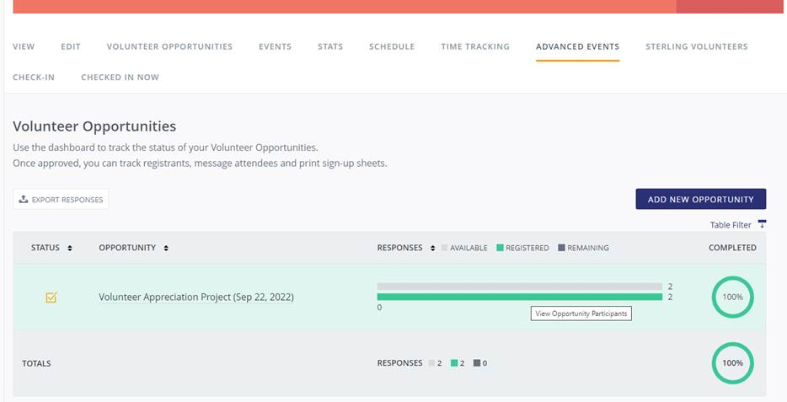
- Once you have click on the volunteer opportunity, then click the green bar to view the listing of volunteers
- Exporting the full list of volunteers will be an option.

HOW TO ADD AN EVENT
- Login your account
- Click on ‘My Agency’ at the top of your window
- Click on ‘EVENTS’ in the middle of your screen
- Click the blue ‘ADD NEW EVENT’ button on the right
- Then fill out the title, description, date, etc. for your event
  - Note: RSVP option works similarly to Facebook RSVP and will just give you an idea to how many people are interested in attending. Each time someone RSVPs to your event, that person and your agency’s manager will get an email notification.
- Then click the blue ‘Create Opportunity’ to complete the process
- If needed: Use the red ‘DEACTIVATE OPPORTNITY’ button on the bottom of your screen
To view your listing, an ‘OPPORTUNITY LINK’ will populate on the right of your screen. Copy and paste that into your browser to view and share your opportunity.
On each new or updated opportunity, double-check the information is correct and ready for sharing.
To update or deactivate your opportunity later, go to ‘VOLUNTEER OPPORTNITIES’ then click ‘Edit’ under the volunteer opportunity you want to deactivate or update.

